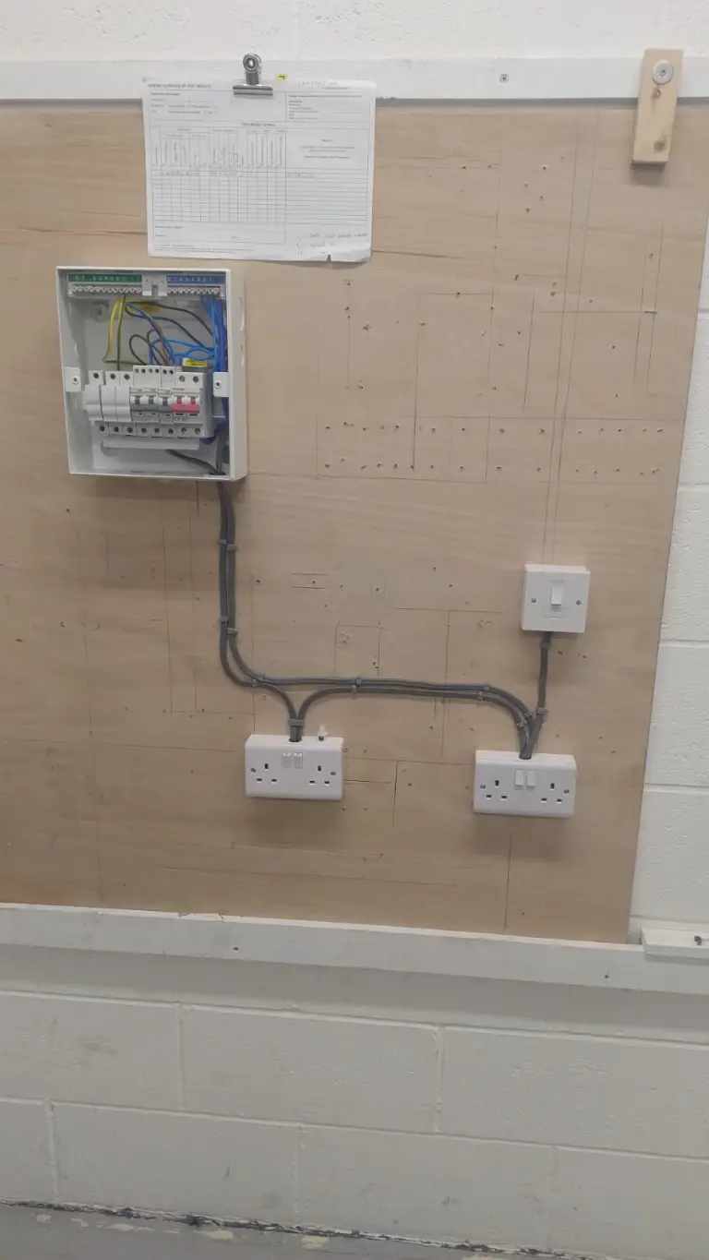

**Circuit G1**

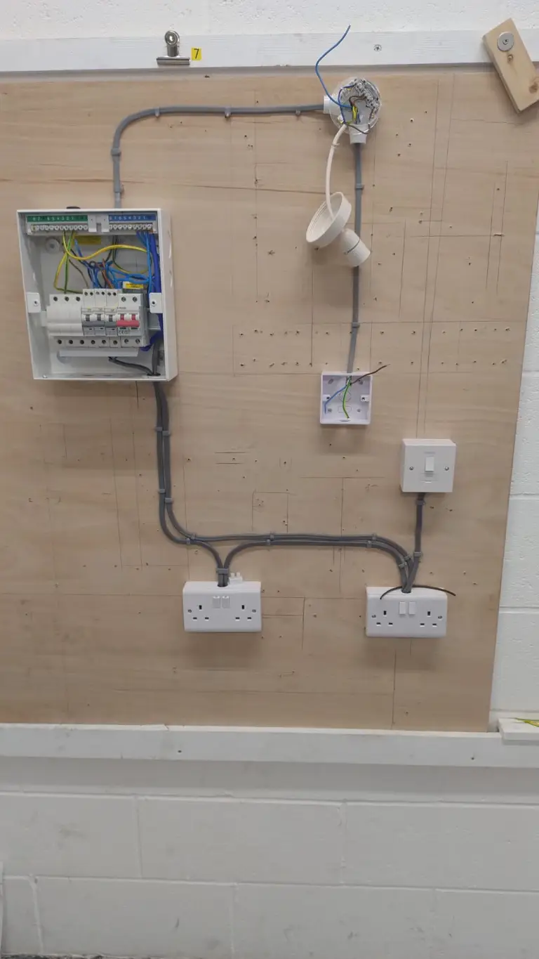

**Circuit G2**

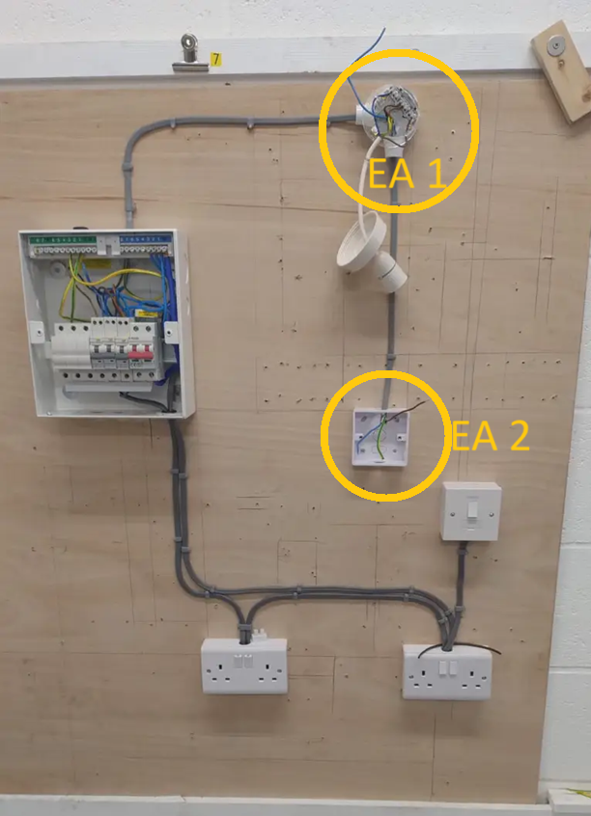

**Circuit G2 with annotations.**

**EA 1 (Electrical Area 1) – is the rose ceiling**

**EA 2 (Electrical Area 2) – is the light switch**

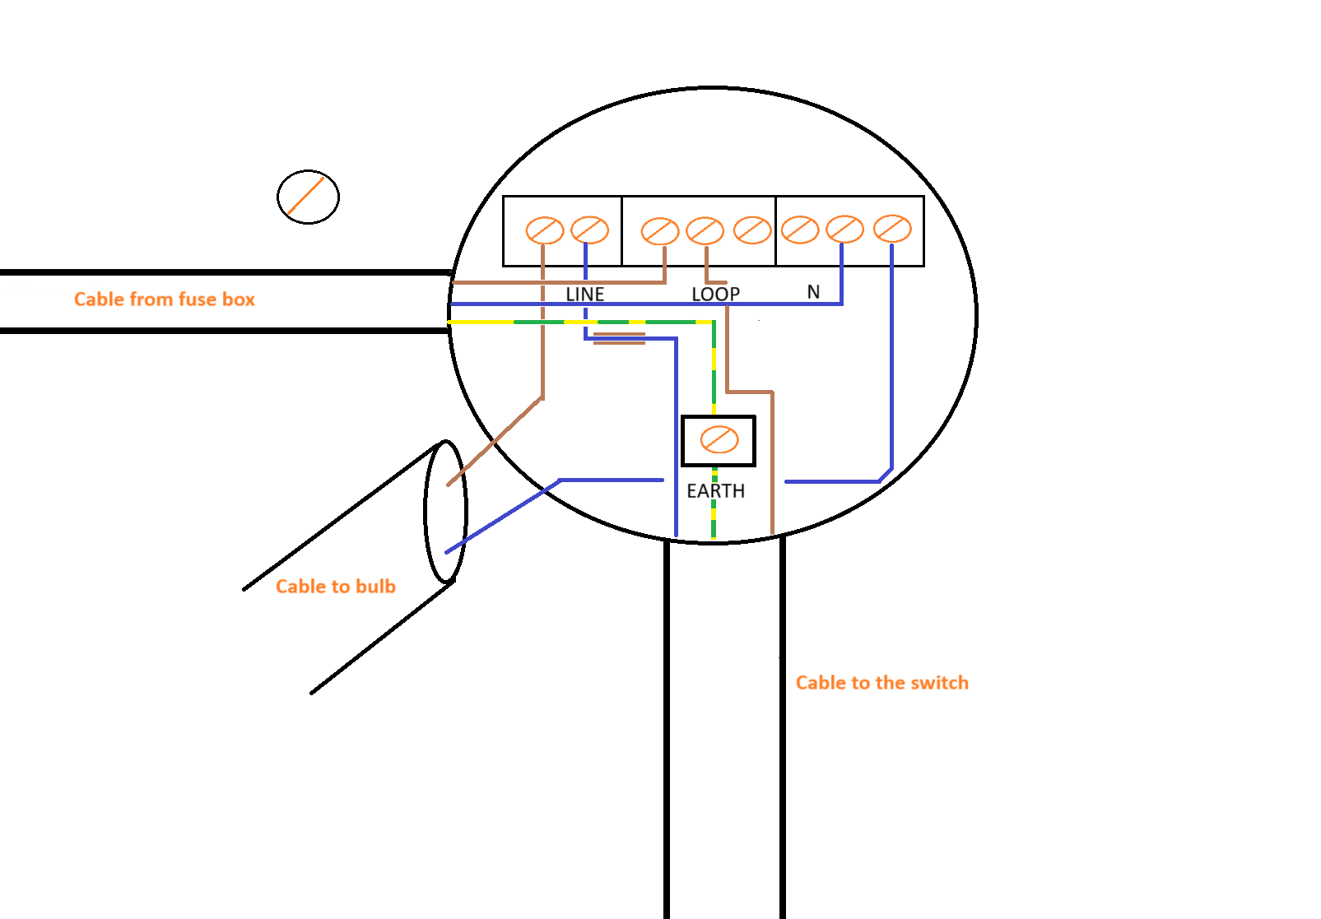

**Long view of EA 1**

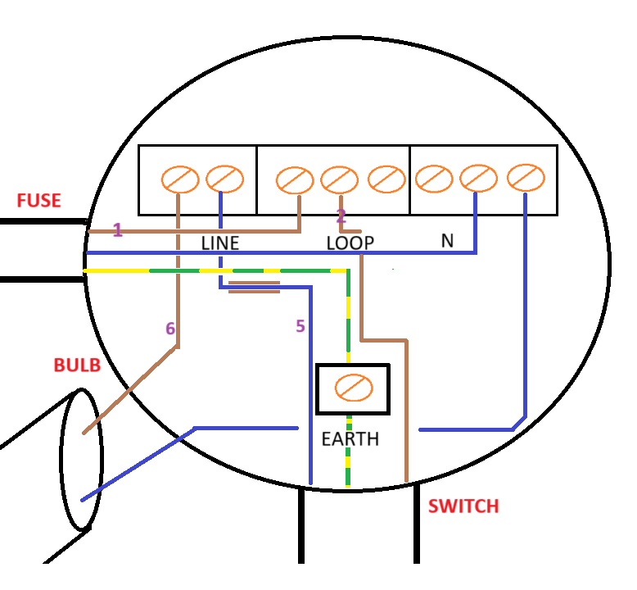**Close up/Detailed view of EA 1**

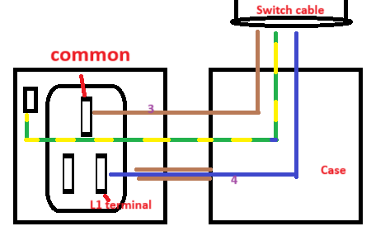

**Detailed view of EA 2**

* **Step 1 – power flows from the fuse’s brown live wire into the Loop segment of the connector block.**
* **Step 2 – In the loop segment of the connector block. The electricity flows from the brown live wire of the Fuse cable to the brown live wire of the switch cable.**
* **Step 3 – the electricity flows down the brown live wire of the switch cable to the actual into the common terminal.**
* **Step 4 – When the “light button” is pressed on. The circuit is complete and the electricity will flow from the common terminal into the L1 terminal. Then from the L1 terminal back into the switch cable, through the switch live wire. The switch live wire is the blue neutral wire with a brown sleeve. It is called the switch live wire because, it gets electrical flow when the “light button” is pressed on – switched on. Hence the name switch live wire.**
* **Step 5 / Step 6 – The electricity flows through the switch live wire into the line segment of the connector block. This grants electricity to the adjacent terminal in the line segment. The adjacent terminal holds the brown live wire for the bulb. Therefore, the electricity then flows down and the brown live wire and the bulb will be lit.**

**Theory**

**Two methods for wiring a light:**

1. **Two plate – goes from switch to light**
2. **Three plate – goes from light to switch**

**Hazardous substances**

**Adhesives – to join a plastic conduit**

**solvents – usually a liquid**

**lubricants – used in the machinery and maintenance**

**jointing compounds**

**cleaning agents**

**SWA cable you can use shoe polish**

**Hazardous substances – How to reduce risk: PPE, ventilations, RA, Method statement and SSOW.**

**Tutor: The majority of the students will have a van and will be on the move. Lock the equipment to the plyboard inside the van.**

**Data sheets used to determine what products to use**

**Do not use different bottle for a different product**

**Use hand protection when you use solvents**

**Barrier cream and after-hand cream**

**A permit to work – who, what when and where?**

**permit to work feeds off from Risk Assessment (RA)**

**Electrical dangers**

* **Checks for faulty equipment should be checked every time before use**
* **Double insulated cable required on wires,**
* **Junction box – one wire goes into junction box and the junction box feeds into many directions.**

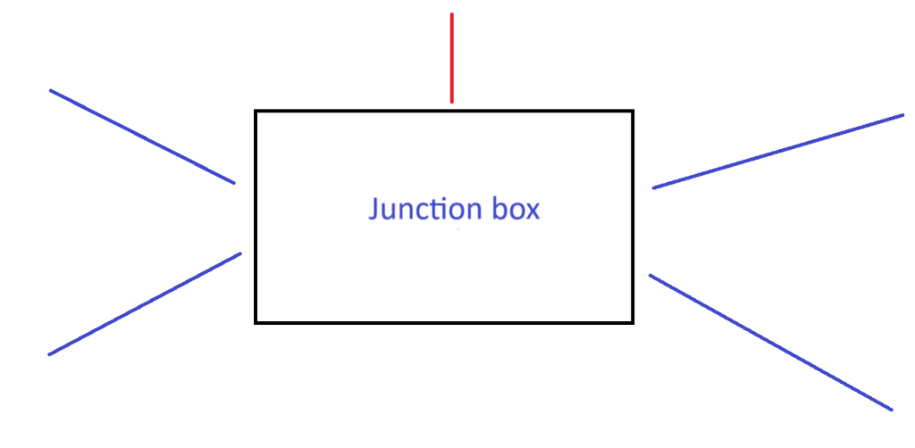

* **The wires should be feeding horizontally or vertically in line with the light switch,**
* **Love voltage increases the current,**
* **55v shock is the max you will receive from 100x equipment,**
* **the max temperature is 70 degrees is because this is the temperature that the insulation will melt. However, the internal copper wire will be fine. Because it takes more than 70 degrees to melt copper.**
* **The warning is for the insulation.**

**Fire and fire fighting**

**Think of regulations as MOT. They test the house(s) against the regulations for when the house was built. If you do a new installation it must comply with recent regulations.**

**Classifications of fires**

* **Class A – Materials,**
* **Class B – Liquids,**
* **Class C – Flammable gases,**
* **Class D – Metals,**
* **Class E – Electrical fires,**
* **Class F – Cooking oils/chip pan fires.**

**Asbestos**

**Type of asbestos:**

* **Chrysotile (white),**
* **Amosite(brown),**
* **and Crocidolite(blue).**

**Additional information:**

* **Causes long conditions,**
* **Test to find if work area contains asbestos,**
* **Keep area damp to reduce the dust in the air,**
* **Asbestos can be taken to local waste plant – ensure it is double bagged.**

**Environmental protection**

**Diesel particule filler (dpf)**

**Three waste disposals;**

* **Recycling,**
* **Hazardous waste,**
* **landfill,**
* **offshore (tutor mentioned).**

**You can strip down cables for copper. Copper is valuable.**

**Give it back to the wholesaler and then get a credit note.**

**Spill kit can be used for diesel and engine oil apply sand on it , when spilt.**

**Petrol evaporates so no need.**

**In the third class we change the ring circuit with a spur and added a radial circuit to it. View the picture below.**